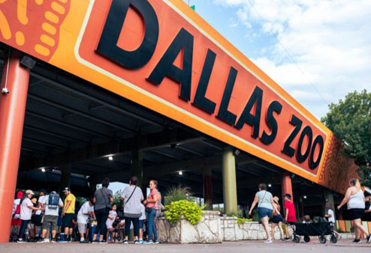

About Dallas Zoo Park

What is Dallas Park Zoo? and where is located established?The Dallas Zoo is a large, well-known zoo located in Dallas, Texas, USA. It is one of the oldest and most prominent zoos in the United States, with a rich history of conservation, education, and wildlife care The Dallas Zoo was established in 1888, making it one of the oldest zoos in the country 650 S. R.L. Thornton Freeway, Dallas, TX 75203, USA.

Opening & Closed Timings

Monday to Sunday: 9:00 AM - 5:00 PM

The zoo is open every day of the week, though hours can change during holidays or special events.

The zoo may have extended hours during special events like Zoo Lights during the holiday season, or summer months when more exhibits are open later in the day.

The zoo has several dining options that cater to families, including cafes and snack stands that provide kid-friendly menus.

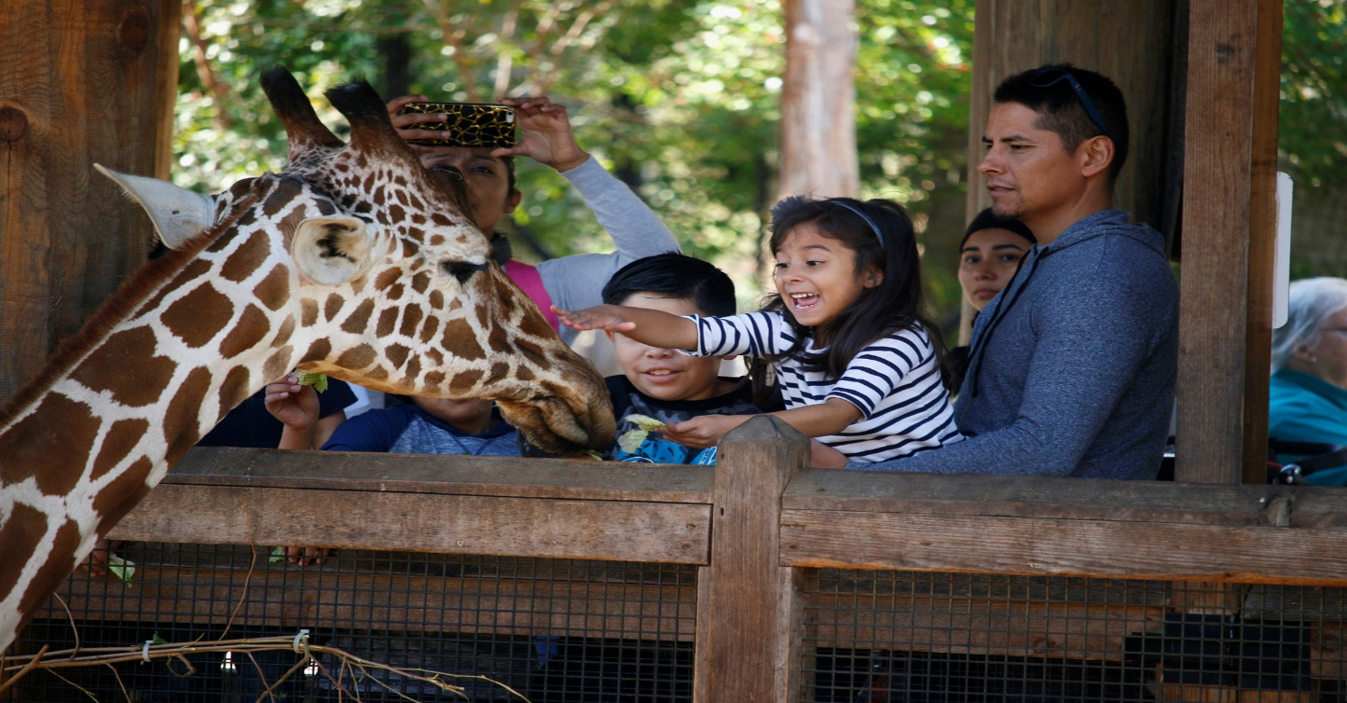

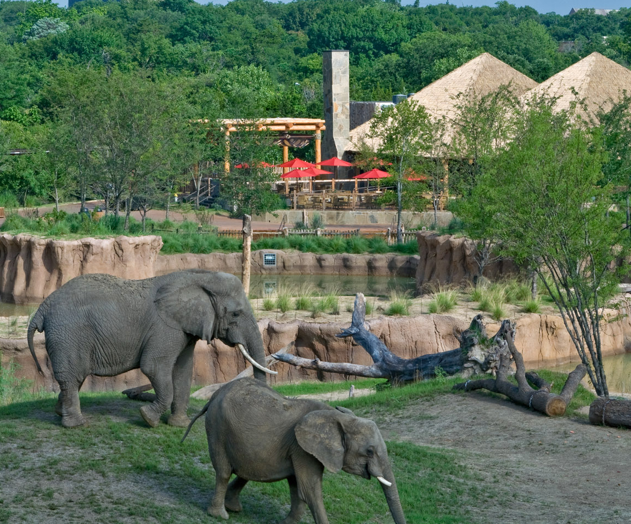

Animals List

The Dallas Zoo is home to more than 2,000 animals representing over 400 species from around the world

Notable exhibits include:

Lions

Zebra

Gorillas

Cheetah

Panda

Koala

Deer

Beer

Snow leopard

Address & Contact

Address: Dallas Zoo, 650 S. R.L. Thornton Freeway, Dallas, TX 75203, USA. For questions related to visiting, opening times, directions, accessibility, or other general information, you can visit their [Support Centre](https://www.dallaszoo.com).

Email: For specific enquiries

you can fill out the contact form available on their ( info@dallaszoo.com).

Phone: For urgent enquiries, you can call their Supporter Contact team at +1 214-670-5656.

For the most accurate and up-to-date information, it's recommended to visit the [official Dallas Zoo website]